MEMORANDUM

TO: | Board of Directors, Buffalo Erie Niagara Land Improvement Corporation
FROM: | Brendan Mehaffy, Vice Chairperson
SUBJECT: | Resolution #: 2017-48 86 Caldwell Place – City of Lackawanna Transfer
DATE: | October 19, 2017

DISCUSSION

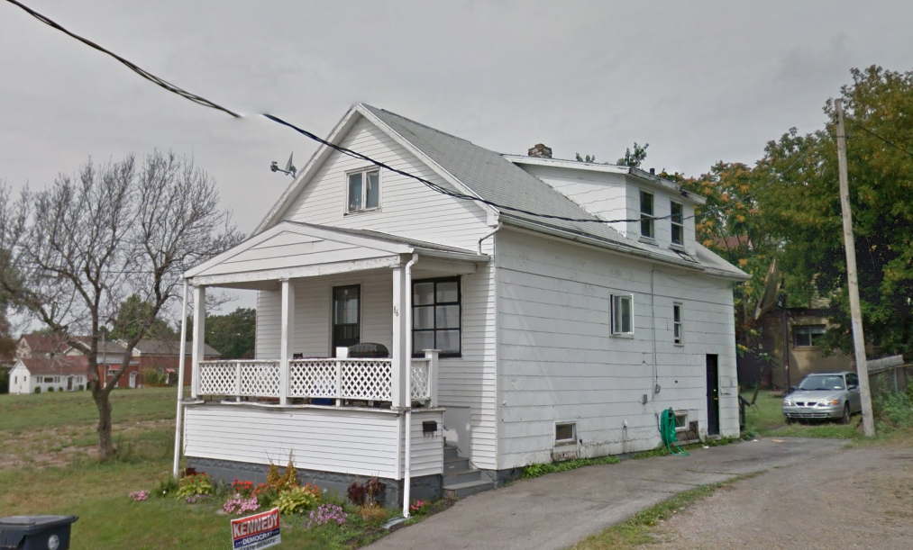
The City of Lackawanna wishes to transfer a city-owned single-family residence located at 86 Caldwell Place (SBL#142.37-4-25) to BENLIC for the sum of $1.00. City officials are interested in the Land Bank’s new Note & Mortgage Program to ensure potential buyers complete necessary improvements to the property. Officials estimate that an investment of $30,000-$40,000 are needed at a minimum, to bring the property into a safe and code compliant condition. The City of Lackawanna Council approved transfer of the property on October 2nd, 2017. Additionally, the Real Estate Selection Committee supports acquisition and resale of the property to continue community development efforts within the city.

ACTION

The Board of Directors is hereby requested to approve the following resolution:

RESOLVED, that the BENLIC Board of Directors approves the acquisition of the property 86 Caldwell Place (SBL# 142.37-4-25) for $1.00 contingent upon the satisfaction of BENLIC counsel that no restrictions, judgements, or liens are found; and be it further

RESOLVED, that BENLIC authorizes Jocelyn Gordon, as Executive Director, along with BENLIC legal counsel to take all necessary actions required to execute an agreement of sale with the City of Lackawanna, close on the property, and ensure that BENLIC holds clear title to the property.

